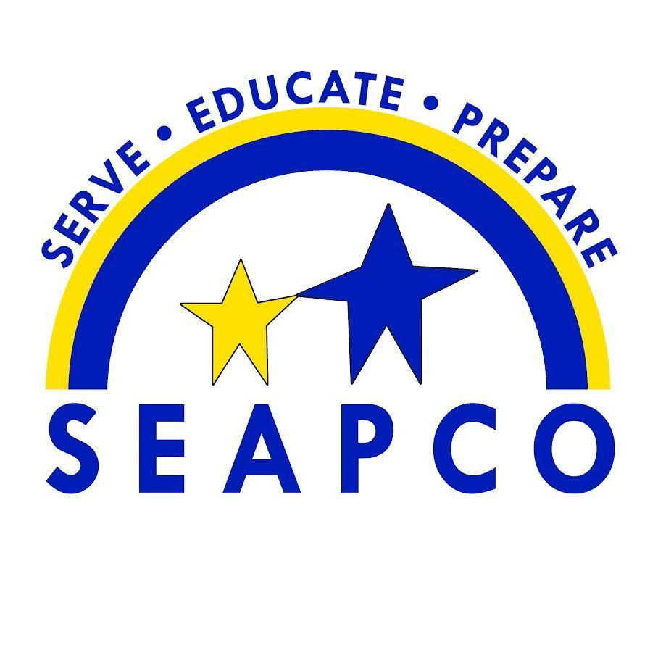

SPECIAL EDUCATION ASSOCIATION OF PEORIA COUNTY
4812 W Pfeiffer Rd., Bartonville, IL 61607
Ph: 309-697-0880 Fax:309-697-0884

Dear Senior,

The Division of Rehabilitation Services (DRS) can assist you in vocational supports (job searches, job coaching, job training, on-the-job supports, etc.) but DRS may also be able to provide financial support if you are attending a community college and your field of study is part of your job/career goal.

Contact the DRS office at 309-671-8580 and leave a message requesting an intake for adult vocational services. Let them know you are a graduating senior and interested in job supports and/or the community college initiative (if planning to attend a community college). Make sure to leave good contact information, phone number and email address so someone can get back to you.

Make sure to keep a copy of your most recent IEP and Re-evaluation to share with them. If you would also like accommodations in college, the college will need a copy of your most recent IEP and Re-evaluation. All colleges have a disability support office, many times called access, accessibility office or disability services. I have listed the contacts for our local community colleges.

- Illinois Central College - https://icc.edu/around-campus/access-services/
  - Access Services – Email: accessservices@icc.edu
  - Placement testing – email: testing@icc.edu . They can set up a testing appointment on campus or remote testing.
- Black Hawk Community College - https://www.bhc.edu/student-resources/disability-services/
  - Disabilities Services Office, Quad Cities Campus –Email – Jen Holldorf, coordinator HolldorfJ@bhc.edu or disabilityservices@bhc.edu
  - Disabilities Services Office, East Campus, Galva, IL – Email – ECDisabilityServices@bhc.edu
- Spoon River Community College - https://www.src.edu/services/Pages/disability.aspx
  - Disability Services - Email – disabilityservices@src.edu

Finally, you may have graduated from SEAPCO and your high school, but feel free to reach out if out if you have questions. I will continue to stay up on resources and you can always email me, jvanderheydt@seapco.org.

Thanks and good luck!

Jodie Vanderheydt, LCSW
Transition Specialist/STEP Coordinator

